**Ideation Phase**

**Define the Problem Statements**

|  |  |
| --- | --- |
| Date | 28 June 2025 |
| Team ID | LTVIP2025TMID2893275 |
| Project Name | Prevent User Deletion If Assigned To An Incident |
| Maximum Marks | 2 Marks |

**Customer Problem Statement Template:**

Customers face issues when trying to delete users who are still assigned to active incidents. This leads to broken workflows and incomplete incident tracking. It creates confusion among team members who rely on accurate assignment records. Delays in incident resolution can also impact service quality and compliance.

They need a way to prevent user deletion unless all incident associations are resolved, ensuring data integrity and system reliability.A clear notification or automatic reassignment process would help avoid accidental data loss. This solution will improve operational efficiency and user confidence in the system.

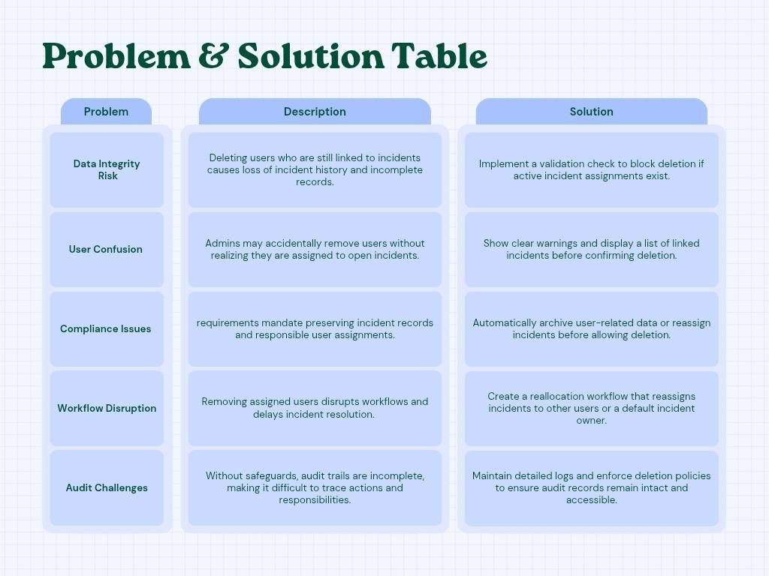

Reference: <https://miro.com/templates/customer-problem-statement/>

**Example:**

|  |  |  |  |  |  |
| --- | --- | --- | --- | --- | --- |
| **Problem**  **Statement (PS)** | **I am**  **(Customer)** | **I’m trying to** | **But** | **Because** | **Which makes me feel** |
| PS-1 | an Admin | Delete a user | the system doesn't allow it | the user is still assigned to active incidents | stuck and confused |
| PS-2 | A Team Manager | Manage  incident ownership | users get deleted without warnings | there's no alert or automatic check for active incident assignments | Frustrated and worried |

✅ **Problem Statement PS 1:**

As an admin, I am trying to delete a user who is no longer part of the organization, but the system prevents me from completing this action because the user is still assigned to active incidents. This limitation makes me feel confused and stuck, as I cannot maintain clean records or reassign responsibilities easily.

It interrupts the workflow and delays task management, especially during critical times. I need a better way to identify and resolve such dependencies before proceeding with deletion.

✅ **Problem Statement PS 2:**

As a team manager, I want to ensure that incidents are properly reassigned when a user is removed. However, the system allows deletion without any warning or summary of assigned tasks.

This causes incidents to be left unmanaged, which affects team performance and service quality. A built-in alert or automatic reassignment would reduce errors and maintain accountability.